CSE3241 In-Class Activity – Embedded SQL Lab
Work individually and turn it in at the end
Name: ____Qifan Wen (wen.679)________________ Date: ___2025/11/14___
For this lab, we will use a Java program to implement several queries which will interact with, display information from, and change the state of a database. The database provided consists of different tables to manage media for a (fictional) establishment called the Groove Record Store. Take some time to get familiar with the program structure and run the program to get a better feel for the menu. You will be completing portions of the menu in numerical order.
Part 1: Downloading and Creating Java Project
- Before starting the lab, download the two files: Java-JDBC-Sample-Application.zip and database_binary.db from Canvas.
  - Open on SQLite Studio the database_binary.db and browse through the different tables to get an idea of the different tables
  - Unzip and import the provided Java project to VSCode and browse through the code, see the comments, instructions and documentation (import project).
The project structure is as follows:
osu.cse3241 contains “GRS.java”, which instantiates the database connection and facilitates the main menu.
=> osu.cse3241.options contains various .java files will correspond to the different menus which will be implemented throughout the lab.
=> osu.cse3241.sql will maintain all the SQL functionality (creating Statements, PreparedStatements, printing ResultSets).
=> osu.cse3241.utilities contains a couple miscellaneous methods and can be ignored.
Part 2: Downloading and Importing the SQLite JDBC Library (.JAR file)
- You need the SQLite JDBC library to successfully run a Java program that accesses an SQLite database. You will need to download it from Carmen and add it to your VSCode project as an external library. To do this, follow the steps below:

- Download the sqlite-jdbc-3.32.3.2.jar.
- Add the jar file to the “lib” folder in the Java project.
  - To add the .jar file to the “lib” folder in your project by dragging and dropping the JDBC file into the lib folder in the project either in VSCode or your file system. Another option is to copy and paste the file into the project lib folder.
  - Note: Visual Studio Code does not provide a direct “Add File” option within the context menu when right-clicking on a folder. Therefore, the external library must be added manually.

Note: For more general information about Installing the Java Database Connectivity (JDBC) API on different DBMS read instructions at:

https://www.codejava.net/java-se/jdbc/jdbc-driver-library-download (links for different DBMS drivers)
https://docs.oracle.com/javase/tutorial/jdbc/basics/gettingstarted.html.

Part 3: Execute the Program
- Compile and run the program.
  - Compile and run “GRS.java” (if you’ve imported it properly it will).
  - If errors are reported, verify that the JDBC library was correctly added (make sure that you configure/add the build-path of the JDBC external jar) and that the database_binary.db is also available in the main project directory.
  - Upon running the program, it will print a message to the console window noting a successful database connection (text-based interface). Feel free to navigate through the different menu options.
  - Examine the code to follow the process connection to that database provided. Note: the method sqlQuery(Connection, String) [osu.cse3241.sql] is using the Statement class (this typically is used for static SQL Select statements), sqlQuery(Connection, PreparedStatement) is using the PreparedStatement class (this typically is used for dynamic SQL statements).
  - Copy a screenshot in the Lab answer sheet (at the bottom of this file) of the console output from the first run.

NOTE: “SQL.java” is meant to abstract all SQL functionality (try-catches, PreparedStatements, Statements) from the rest of the program. If a menu option is not working, check and verify that everything is implemented correctly in this file first.

Part 4: Implementing “View all Artists/Tracks”
Navigate to “osu.cse3241.options.ViewArtistTrack.java”. Implement a simple search by either Artist or Tracks by completing one of the private methods viewTracks() or viewArtists(). Ensure that all table columns are printed. Provide the implementation for the static query with good practice. Run the menu option and provide a screenshot when completed.

Part 5: Implementing “Search Artists/Tracks”
Navigate to “osu.cse3241.options.SearchArtistTrack.java”. Implement the conditioned search for either Artist or Tracks (whichever you chose to implement in the prior section) by completing one of the private methods searchTracks() or searchArtists(). For Artist, the search criteria will be composed of Artist_Name. For Track, the search criteria will be composed of Track_Name. Provide the implementation for the dynamic query with good practice. Run the menu option and provide a screenshot when completed. Note: be sure to reference corresponding method(s) in “SQL.java” to understand the usage of PreparedStatement.

Part 6: Implementing “Search Record Stock Count”
Navigate to “osu.cse3241.options.SearchRecordStockCount.java”. Implement “Search Number of Records in Stock”, using search criteria of Album_Name. Method skeletons will be provided for you, but you are on your own to complete the rest (should be similar in implementation to the prior two parts). Note that you will need to complete both the corresponding methods in SearchRecordStockCount.java and SQL.java. Provide the implementation for the dynamic query with good practice. Run the menu option and provide a screenshot when completed.

Part 7: Implementing “EDIT MENU”:
Navigate to “osu.cse.3241.options.EditMenu.java”. In practice, this kind of window might have various other options to edit multiple different tables, but we are only going to focus on the “ARTIST” table for simplicity. Within the “EDIT MENU”, implement functionality for insertion of a new ARTIST tuple by completing the method addArtist() and the method you will define in SQL.java (you do not have to implement any other options). Refer to the comments within “EditMenu.java” for pointers on implementation structure. Provide the implementation for the dynamic query with good practice. Run the menu option and provide a screenshot when completed; include an additional screenshot showing the new addition into ARTIST by a query in the SQLite editor.
Embedded SQL Lab Answer Sheet

Part 3: Execute the program and paste a screenshot of the main menu + successful connection message.

Insert screenshot(s) of the execution.
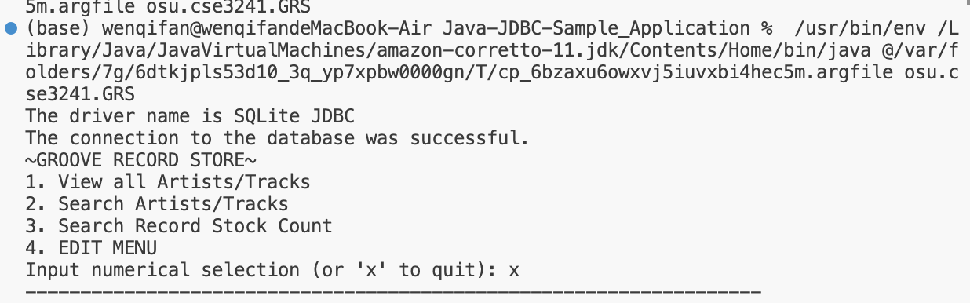
Part 4: Execute the program and paste a screenshot of whichever approach you chose to implement using menu option "View all Artists/Tracks”.

Insert screenshot(s) of the execution.
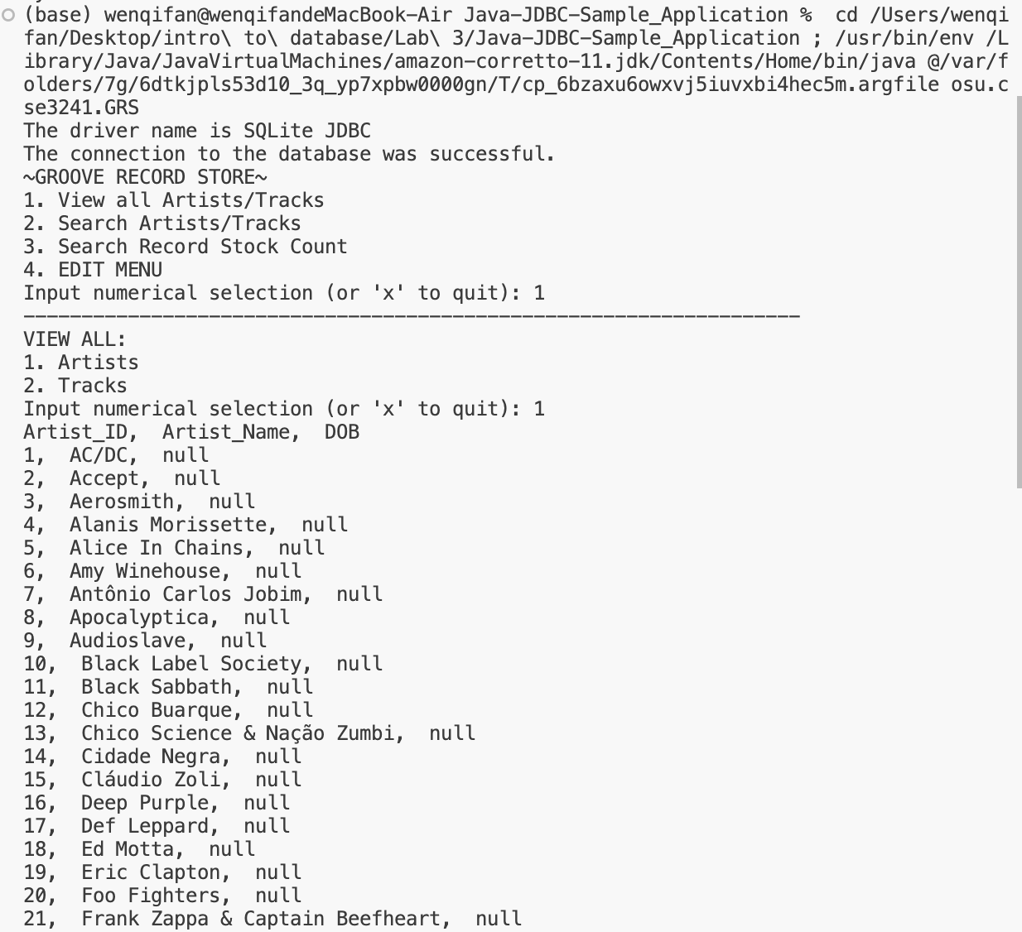
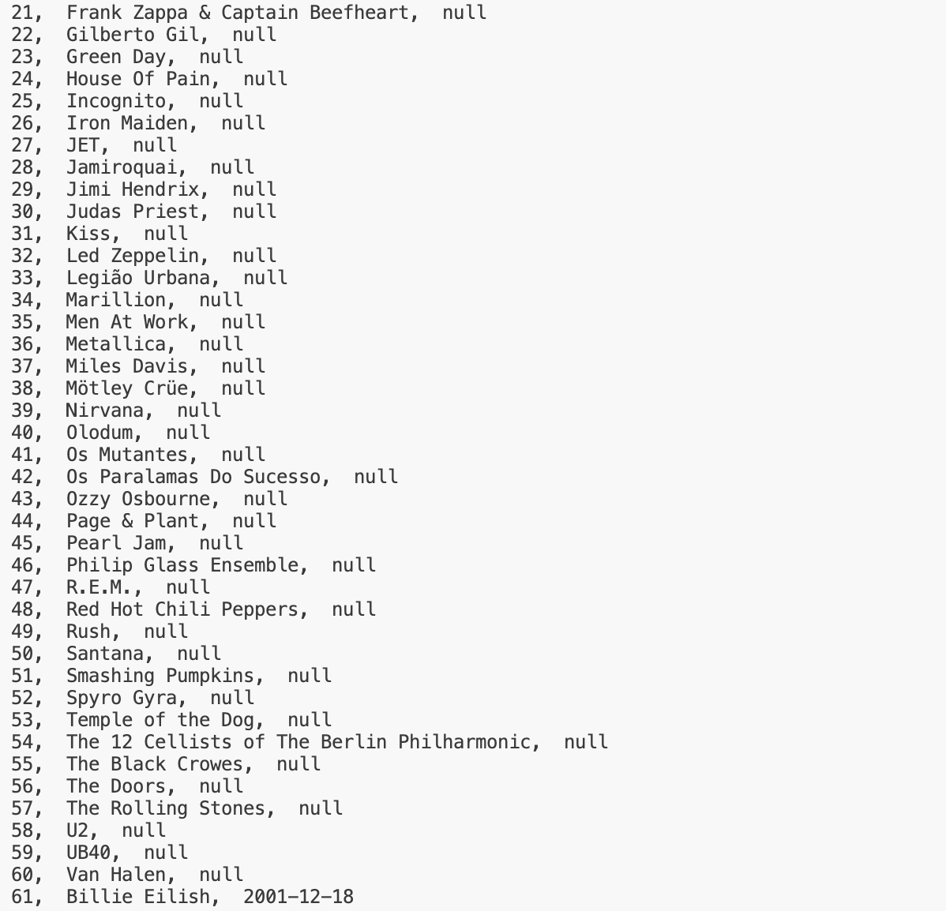
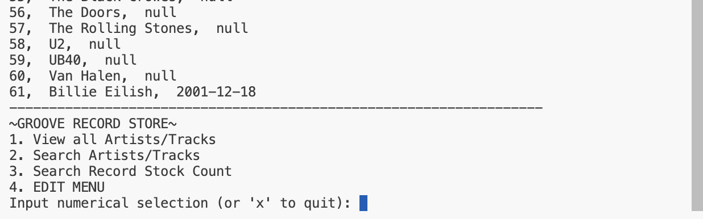
Part 5: Execute the program and paste a screenshot of whichever approach you chose to implement using menu option "Search Artists/Tracks”. (The same approach should be taken in the prior option.)

Insert screenshot(s) of the execution.
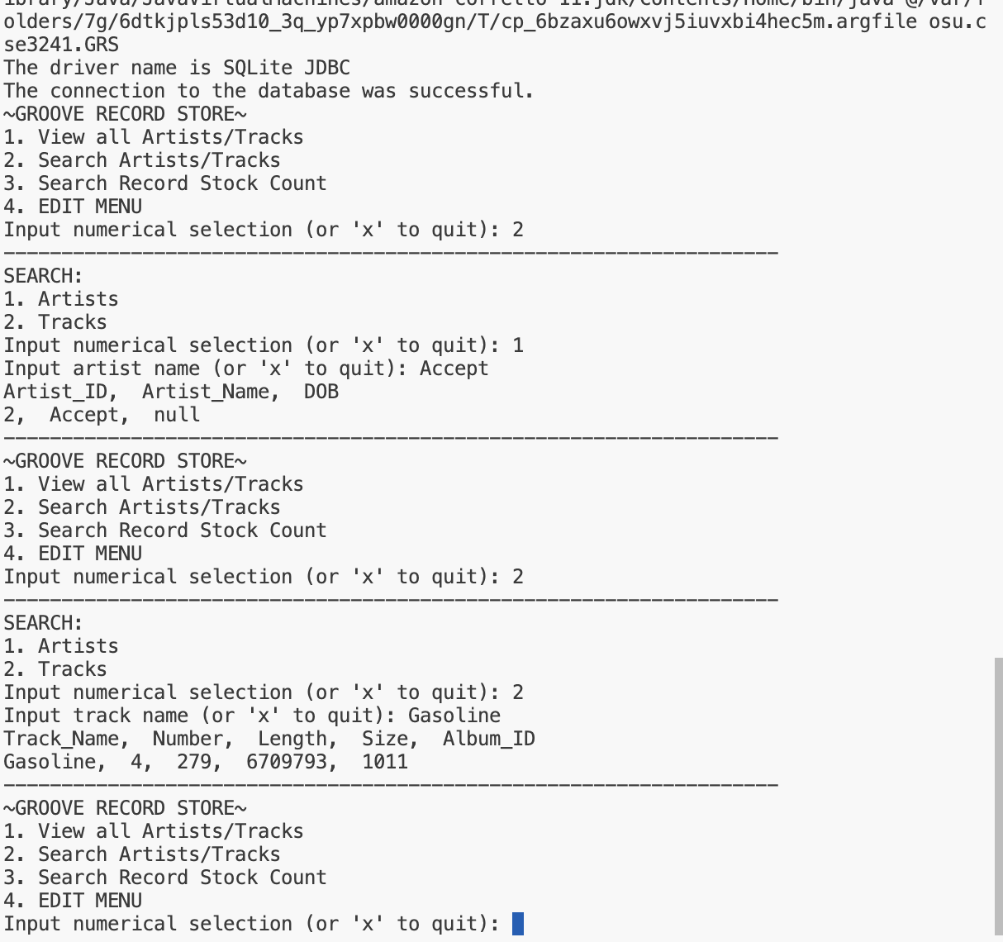
Part 6: Execute the program and paste a screenshot using menu option “Search Record Stock Count”.

Insert screenshot(s) of the execution.
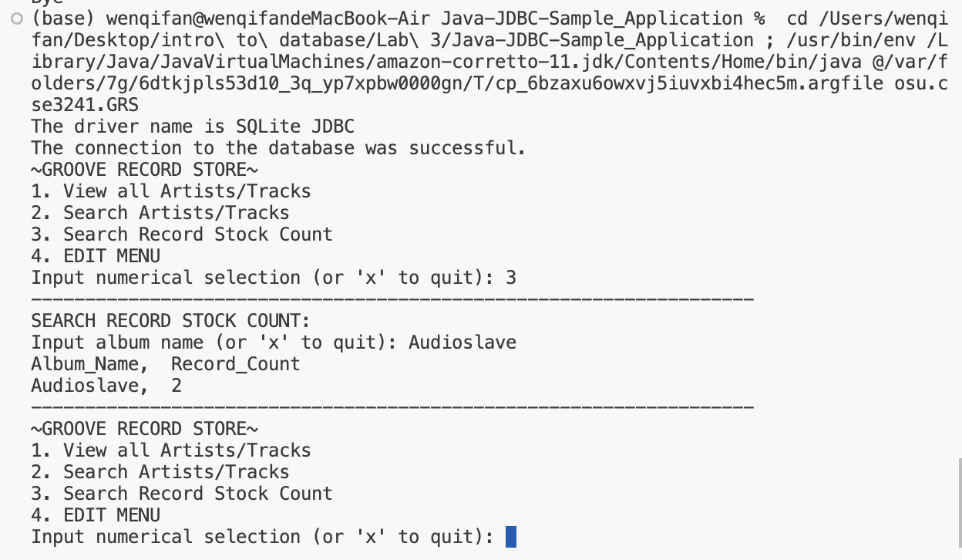

Part 7: Execute the program and paste a screenshot using “Edit Menu” option “Add Artist”. Additionally, include an additional screenshot showing the new tuple inserted into ARTIST by using a query in the SQLite editor.

Insert screenshot(s) of the execution, inserted tuple in SQLite Studio.

